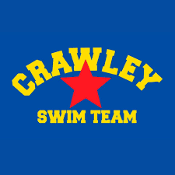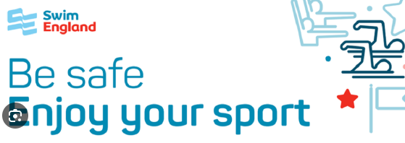

The Menstrual cycle and Swimming at CSC

What is the Menstrual Cycle?
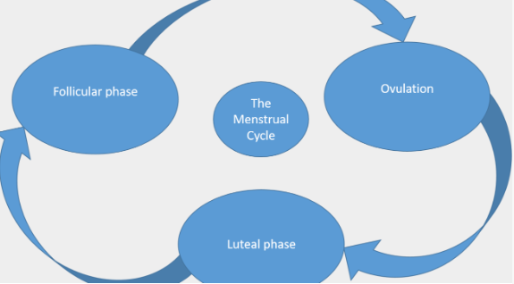
The menstrual cycle is normal in girls and women and it is perfectly safe to still go swimming when bleeding on a period. It starts during puberty and is a sign that a girl’s body is preparing for reproduction. There are lots of changes that occur to a girl’s body during this stage in life such as breast enlargement, pubic hair growth, under arm hair and increased fat mass around the hips which are all a normal part of becoming an adult.
Menstruation also known as the period is the time when a girl bleeds and is normal in healthy females. The bleed can last between 3 and 8 days normally and occurs on average every 28 days in a normal cycle but can vary between 21 and 45 days when you first start your period. Eventually this will settle down to 21-35 days. The average age for a girl to start her period is 12, but it can vary between 8 and 15 years of age.

Common signs and symptoms that may occur during the monthly cycle
The changes in hormone levels can cause different symptoms across the menstruation cycle. The main negative signs and symptoms are listed below, but sometimes girls may feel very confident, have lots of energy and focus.
- Bleeding for 3-8 days
- Pain during the first few days of a period
- Cramping of the stomach
- Bloating
- Mood changes such as feeling weepy, irritable, tired
- Reduced concentration
- Breast tenderness
- Temporary weight gain
- Headaches
- Low back pain
- Food craving

Some ways to help your symptoms
- Pain can be eased by a warm bath, hot water bottle or pain relief. Gentle exercise can also help reduce pain
- Sleep can help reduce tiredness
- Good nutrition including fruit and vegetables
- Tell your coach so they can make some allowances for your cycle
- Be prepared and have a small bag in your kitbag with menstrual products in. Keep the pack in your swim bag.
- Include the following: Spare pair of pants, tampons or period pads, two Paracetamol for pain relief.

Training and competition when having your period

Training when having your period
- Use drag shorts over your costume or shorts on poolside for land warm up. Have a conversation with other girls in the squad to help each other by all wearing shorts on poolside.
- Gentle exercise is often good for pain relief so gentle swimming is a good way to ease pain. The coach may be able to change the session to reduce the intensity of the exercise.
- It may be useful for you to track and monitor the periods using an app or writing in a training diary.
- Girls should try to talk to the coach so they are aware of when they are having your period.
- The coach should not penalise an athlete for having your period but should recognise it and manage it positively.
- They may be able to alter the training session to account for the period.
- Your privacy and dignity should be maintained at all times by the coach and other team members.

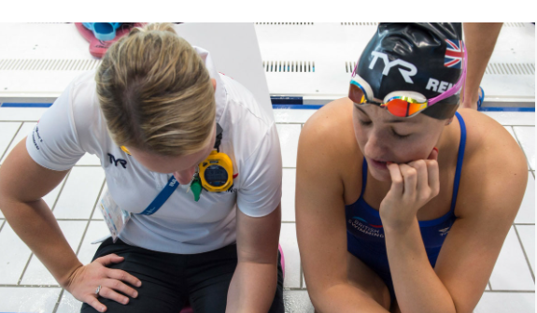

Managing your period during a competition
Many swimmers may use birth control to manage their periods, wear tampons or use a menstrual cup.
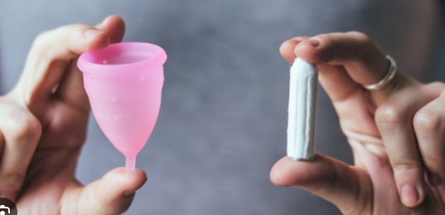

In all Swim England events it is now acceptable to wear period bikini bottoms under a race suit.
An example could be period swim bikini briefs made by WUKA.
Link to Wuka website.
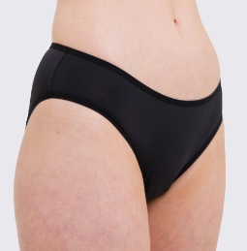
Can I wear Period pants or Swimwear in training and competition?
A specific period swim costume can be worn during training (at any time) or where competitions are held under Swim England Laws and Regulations. This includes all unlicensed and licensed swimming competitions, including Swim England national competitions across both age group and Masters Swimming.
Period pants can be worn underneath a race costume during training (at any time) or in competition at all events held under Swim England Laws and Regulations. This includes all unlicensed and licensed swimming competitions, including Swim England national competitions across both age group and Masters Swimming.
All items worn in competition must be made of textile material as per the current World Aquatic Rules. A swimmer can not wear two full swimming costumes when racing.

SE guidance around period wear.
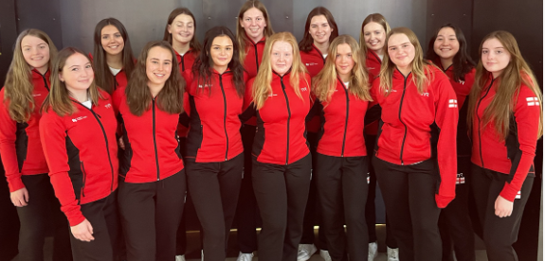
Top tips for race day:
- Use a robe to put on after the race to cover up
- Use shorts on pool side to do exercises
- Inform the team manager and coach
Swim England has lots more information to support: Swim England advice.
British Swimming article about periods in sport: Link
The NHS has advice too: NHS advice link.
Document completed by S J Valovin 01.03.2024

