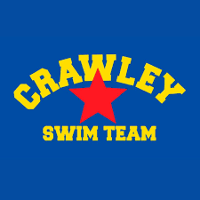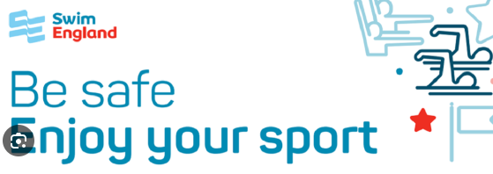

The Menstrual cycle and Swimming at CSC

Most girls start their periods when they're about 12, but they can start as early as 8, so it's important that you feel prepared.

Periods are completely normal and natural – they are part of growing up.

A period is the part of the menstrual cycle when a girl or woman bleeds from her vagina for a few days. For most women this happens every 28 days or so, but it's common for periods to be more or less frequent than this, ranging from every 23 days to every 35 days.

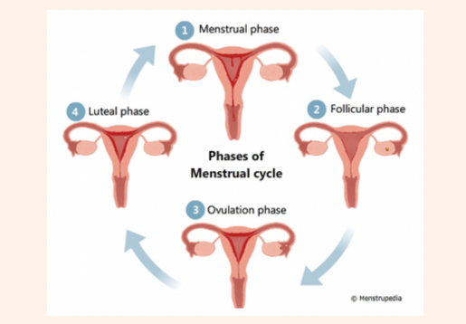

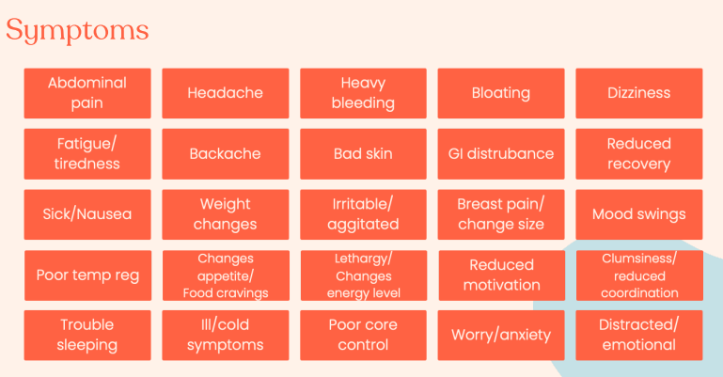

Boys also need to learn about periods. Boys need to be aware about the practicalities, mood changes that can come with periods, and the biological reason behind periods. It will keep them informed, as well as help them to understand about periods.

When a girl starts her periods it's a sign that her body is now able to have a baby. It is also important that you also know about getting pregnant and contraception.

At Crawley SC we want to support all our female swimmers during their menstrual cycle.
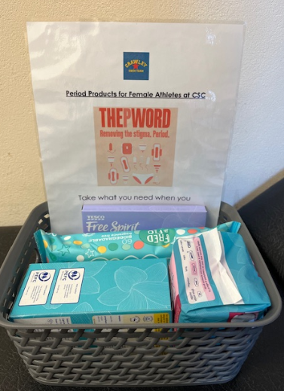

With this in mind we have a basket at the K2 pool and at the Horley pool , which has period products for use which includes tampons, pads and period pants. The baskets are kept in the first aid rooms and you can take what you need, when you need.

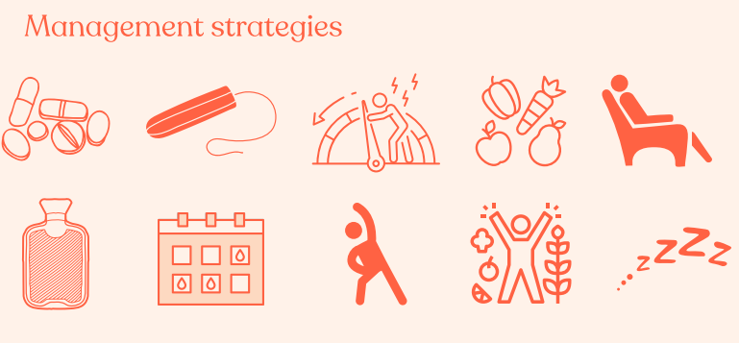
At Crawley SC we would advise all female swimmers aged 10+ to have a small make up bag with spare knickers inside as well as their preferred period protection inside their swimming bag for any emergencies.

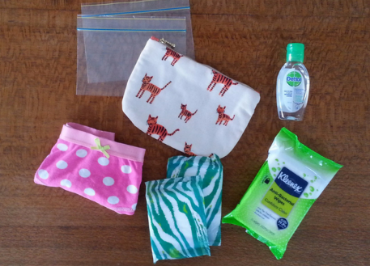

Swimming during your period

Training can actually help improve some period symptoms. Swim England has lots of advice for swimming and competition during your period.
Link: https://www.swimming.org/sport/training-competition-period/
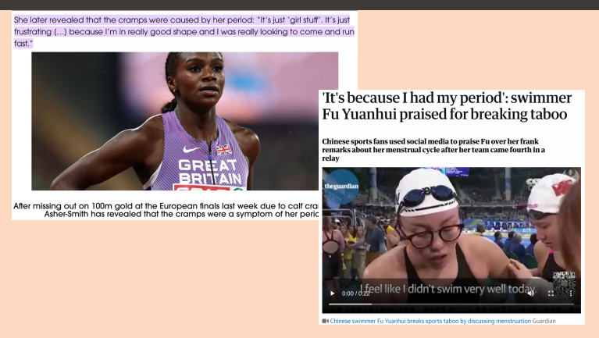
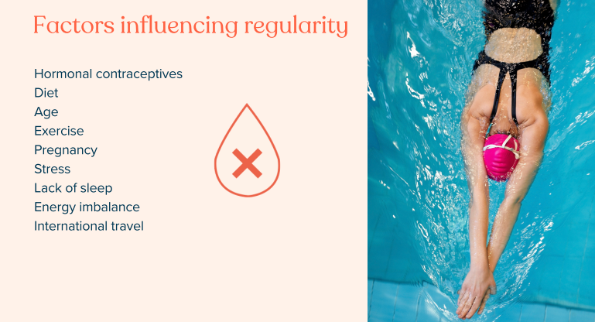

Further Advice for Parents:
NHS Starting your period
https://www.nhs.uk/conditions/periods/starting-periods/#:~:text=Try%20to%20talk%20about%20periods,language%2C%20like%20%22vagina%22.
Video from Always
https://www.youtube.com/watch?v=vS4hpqu37ms

Further reading for Girls
- "Susan's Growing Up" is a picture book about periods that has been specially developed for people with learning disabilities. It's from the Books Beyond Words series from the Royal College of Psychiatrists.
- "The Period Book: Everything You Don't Want to Ask (But Need to Know)" by Karen Gravelle, and published by Piatkus, is a well-known book for any girl approaching puberty. It explains what to expect and how to cope with periods.
Document completed by S J Valovin 01.03.2024

