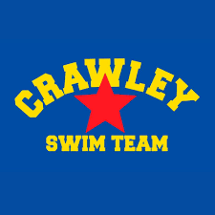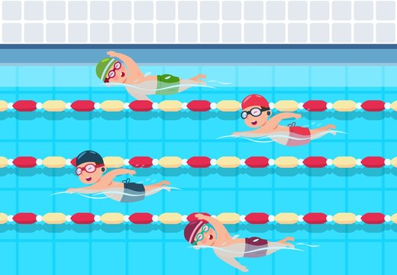
Code of Conduct for Parents and Guardians

As a registered Swim England Member, and parent/guardian of a Member (under 18 years of age) at the Club, or a parent/guardian of a Club Member (under 18 years of age) but not a registered Swim England Member yourself, you are required to agree to this code of conduct.

As a parent/guardian you have the right to:
• Be assured that your child is safeguarded at all times during activity with the club.
• Know who the Welfare Officer(s) is/are and how to contact them.
• Be informed of Wavepower and appropriate safeguarding and welfare reporting procedures.
• Know that any concerns about your child’s welfare will be listened and responded to.
• Know that anyone training or looking after your child at a club activity has the appropriate qualifications, checks and training.
• Be informed of any problems or concerns relating to your child raised by their coach.
• Know how to access the club policies, rules and procedures including the club complaints process and who to contact.
• Provide your consent or otherwise for photography and trips away.

As a parent/guardian of a Club Member (under 18 years of age) we expect you to:
• Make sure your child has the right kit for training and competitions.
• Ensure your child arrives to sessions on time and is picked up promptly.
• Let the club know if you’re running late to collect your child, if your child is going home with someone else or you have made alternative arrangements.
• Complete all consent, contact and medical forms and update us straight away if anything changes.
• Respect the decisions made by your child’s coach or teacher but understand you have the right to raise any concerns regarding your child. We will arrange a mutually convenient time so you can talk to us.
• Remember that children get a wide range of benefits from participating in one of our sports, including making friends, having regular exercise and developing new skills. It’s not all about winning.
• Not enter poolside or interrupt training or competitions unless in an emergency situation.
• Talk to your child and ensure they understand the rules of the club and the sport.
• Ensure your child understands the Athlete Code of Conduct.

We expect certain standards of behaviour from all club members as well as parents,
Guardians and grandparents.

By agreeing to this Code of Conduct you agree to:
• Behave positively as a spectator at training or competitions and treat others with respect.
• Give encouragement to your child well and provide support when they are struggling.
• Respect and celebrate differences in the club and not discriminate against anyone else on the grounds of gender, race, sexual orientation, faith, ability, or any other relevant characteristic.
• Respect anyone competing for other teams at competitions.
• Respect all volunteers, committee members, coaches and teachers at the club.
• Understand that the use of abusive or inappropriate language, bullying, physical violence or any other behaviour which hurts others will not be tolerated at the club.

Breaches of this Code of Conduct will result in disciplinary action being taken against you by the club committee and any behaviour which may be a criminal offence will be reported to Police and any other relevant authority, by the club.

Wavepower Version 2 change:
Continued breaches of this code of conduct by a parent/guardian (whether a member or not) may require the club to stop your child’s continued participation in club activity.

Name of child/children:

Signature of parent/guardian:

Reviewed 09/2024

