

Boys and The Menstrual Cycle Talk at CSC

Puberty is the perfect time to introduce the concept of periods to boys.
Girls and boys experience many similar things – such as getting taller, growing hair under the arms and in the pubic area, and feeling new emotions – but that some things are different.


For boys:
Boys have testicles where they start to produce sperm during puberty.
Sperm is needed to help make babies.
For girls:
Girls have ovaries, which contain eggs, and a uterus, where a baby can grow.
Every month or so, an egg is released from the ovaries. If this egg is fertilised by sperm, it will then lodge in the lining of the uterus and develop into a baby.
If the egg isn’t fertilised, the lining comes out of the vagina approximately once a month, as a period.
This monthly process is called the menstrual cycle and is a normal, healthy process a girl’s body goes through.
Girlsl might use period products during their periods such as pads, tampons, period pants and menstrual cups.
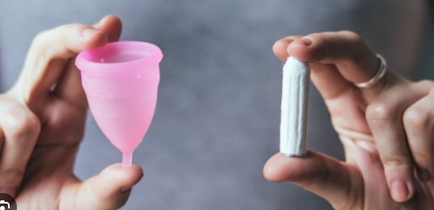
Girls may also experience pre-menstrual symptoms such as cramps, headaches and bloating. They may also feel more sensitive in the run-up to their period and that you shouldn’t take this personally – it might just be to do with their changing hormones.
It is really important for boys and girls to support each other through puberty, and be mindful of each other’s feelings.


Do’s and Don’ts for Parents
When explaining puberty to your son and talking about periods…
DO be clear and concise
If words like ‘uterus’ and ‘vagina’ are new to him, make sure you clearly explain their meaning.
DON’T use euphemisms
While you might need to explain any slang terms he’s heard, like ‘on the rag’ and ‘Aunt Flo’, use the correct terminology to avoid perpetuating the idea that periods are to be kept hidden or ashamed of.
DO encourage empathy
Talk to him about having a quiet word with a girl to let her know if she’s leaked on her skirt, rather than commenting on it to his friends.
DON’T let him tease girls
Explain that making jokes about periods or teasing a girl because you see pads or tampons in her bag is not a nice way to behave and can make a girl very upset.
DO keep things positive
Avoid any language that inadvertently makes menstruation sound negative or in any way dirty.
DON’T dodge questions
If he asks a question when you’re busy – or if you don’t have the answer – don’t brush it off. Respond as best you can and, if necessary, come back to it later.

Document completed by S J Valovin 28..05.2024

