CSC Welfare Team
Our Club Welfare Officers are: Sarah Valovin, Emma Best, Megan Underhill and Stuart Young

Our email addresses are:

welfare@crawleysc.co.uk welfare.emma@crawleysc.co.uk

welfare.stuart@crawleysc.co.uk welfare.megan@crawleysc.co.uk

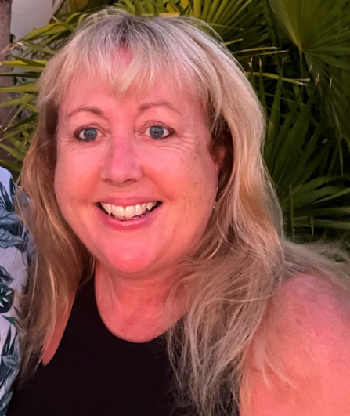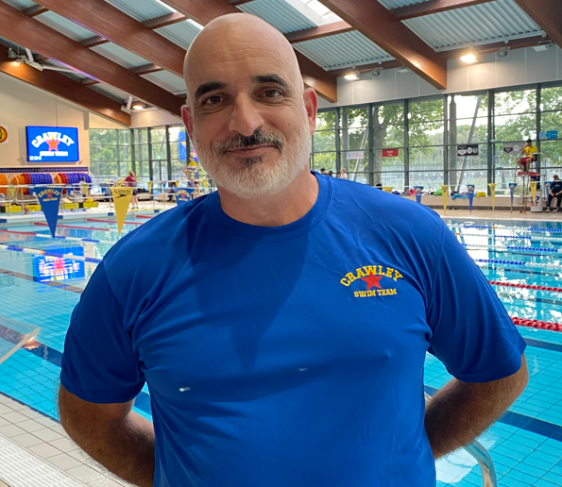
Here’s a little information about our Welfare officers:
Sarah Valovin
I am delighted to support CSC as part of the Welfare Team. My two teenage daughters both enjoyed swimming with the HP squad. My background is within Primary Education and I teach part time at a school in Tilgate, Crawley. I love the countryside, Zumba, cooking and being busy. As a Welfare Team our priority is to help make sure that all the CSC Club swimmers enjoy their sport in a safe, secure and supportive environment.

Emma Best
Emma joined the club in May 2022 when her son began swimming with the Academy Squad. Since then she has dusted off her goggles and joined the Masters in March 2023. When away from the pool, Emma enjoys reading, walking her Labrador, Crumble, on the Ashdown Forest and spending time with her friends and family.

Stuart Young
I am a serving police officer of over 26 years experience, currently working with the local community. As a youth I swam competitively and played league water polo in Northumberland. I have been an active parent in assisting at events for the last 5 years; with a daughter that has progressed through the squads. I am happy to be approached by parents and swimmers alike and will do my utmost to assist where I can.

Megan Underhill
My name is Megan and I am the parent of a child in the Junior Squad. We joined Crawley Swimming Club last year after moving back to the UK from living in Singapore for several years. My background is in teaching, and I have been Head of Year in secondary schools in the UK and in Singapore with responsibility for pastoral care, safeguarding and pupil welfare. In my spare time I am a keen musician, singing in a choir, playing the piano at weddings and other events, and writing pieces for established choirs and instrumental groups. I am looking forward to joining Crawley's welfare team and supporting the club members and their families

If you would like any more Safeguarding information please make contact with the following agencies:
Swimline: 0808 100 4001
Child Line: 0800 1111
NSPCC Helpline: 0808 800 5000
Whistleblowing Advice Line: 0800 028 0285

Local Authority Designated Officer (LADO)
If you would like to speak to the LADO for advice, please contact the team:
- Email (secure): LADO@westsussex.gov.uk (secure)
- Phone: 0330 222 6450

West Sussex Children Services

- Email: WSChildrenServices@westsussex.gov.uk - please include your address and phone number
- Phone: 01403 229 900
- Multi Agency Safeguarding Hub (MASH), 4th Floor, County Hall North (Parkside), Chart Way, Horsham, West Sussex, RH12 1XH

You can also visit the following websites:
www.kidscape.org.uk www.worriedneed2talk.org.uk
www.childline.org.uk www.there4me.com
www.bullying.co.uk

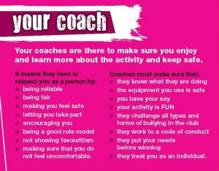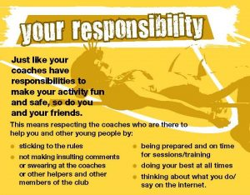

Crawley Swimming Club is particularly keen to safeguard members who are vulnerable. With this in mind, our welfare team, teachers and coaches, team managers and support staff (working with children) have completed the course ‘Safeguarding and Protecting Children in Sport’.
In addition Sarah and Stuart have completed the ‘Time to Listen’ course run by Swim England in consultation with the NSPCC. Emma and Megan will be completing this course shortly.

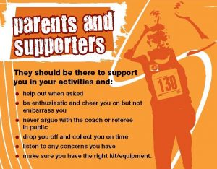
Any individual working with children or vulnerable adults will have a current DBS check in place.

However, we do not claim to be experts, we are very aware that many issues, especially those involving Child Protection, can be exceedingly intricate and potentially life threatening. We fully acknowledge that we will not have the knowledge or skills to be able to deal with every eventuality.
We are therefore very pleased to be able to call on the professional support that Swim England has made available. We will continue to make good use of such support as and when the need arises.
Please remember that we are a Club and that we all have an important part to play in maintaining the safety of ourselves and our fellow members. Please help lookout for the vulnerable and bring safety related concerns to the attention of myself or one of my colleagues as soon as possible.
We operate a ‘code of conduct’ policy for all Parents, Members, Swimmers, Teachers, Coaches and Officials. We follow the Swim England Wavepower Child safeguarding policy and procedures for clubs.
If you have any concerns about your own swimmer or any swimmer within the club please contact our Welfare Team immediately via our referral form on Team Unify or via email on:
welfare@crawleysc.co.uk

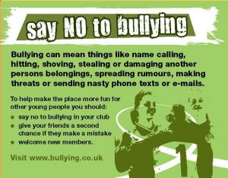

Mental Health Advice for Swimmers

One in four people will experience a mental health problem in any given year – that could be two or three in every race at your next competition.

Mental health problems can effect anyone, and have a wide range of causes that can be complex and interrelated.

Here is a useful flow chart for how to get help for mental health problems:

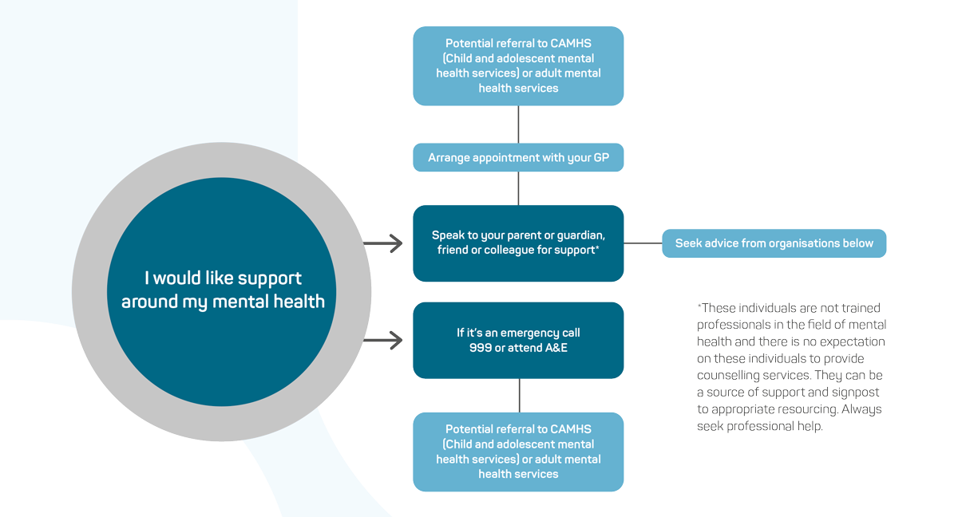

Mental health helplines available:

Samaritans: Free phone: 116 123
Web: samaritans.org/how-we-can-help/contact-samaritan/

Mind: Helpline: 0300 123 3393 Text: 86463
Web: mind.org.uk/information-support/helplines/

NHS: Web: nhs.uk/conditions/stress-anxiety-depression/mental-health-helplines/

The Mix: Free phone: 0808 808 4994 (13:00 – 23:00 daily) Web: themix.org.uk

Self-harm:
Web: youngminds.org.uk/youngminds-professionals/our-projects/no-harm-done/

BEAT (beating Eating Disorders): Helpline: 0808 801 0677
Youthline: 0808 801 0711 Web: beateatingdisorders.org.uk/

